BEFORE READING THE TEXT

What do you know about the eating habits of the British and the French?

Find two differences in their eating habits

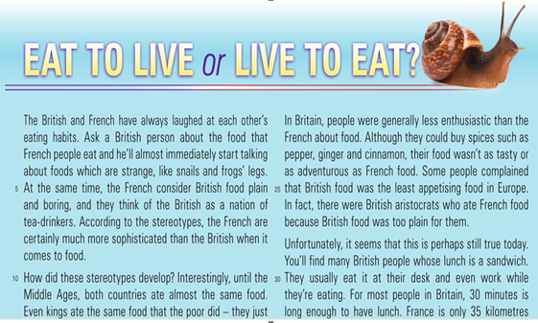
Now read the text

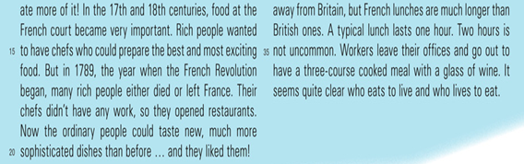
DURING THE READING
Underline unknown words and try to guess their meaning.
Summarize in a sentence what each paragraphs explains

AFTER READING THE TEXT

1. Are this sentences true or false? Which sentences in the text tell you the correct answer? Galdera zuzena.
· According to stereotypes, the French eat unusual small animals.
· The French think the British eat very unusual food
· In the Middle Ages, kings ate the same types of food as por people.
· Aristocrats in Britain enjoyed eating British food.
· Today, many British people continue working while they have lunch.
· Both the French and the British often have sándwiches for lunch.

2. Complete the sentences. Type the answers. Galdera zuzena.
· In the 17th-century France, rich people wanted good chefs because …
· Many chefs lost their Jobs bacause of the French Revolution, so …
· It´s surprising that British food was not as tasty as French food because …
· The British don´t take as much time as the French to …

3. Find words or phrases in the text to match the descriptions below. Type the answers. Interpretazio galdera.
· Routines or things you do frequently (lines 1-9)
· Normal (lines 14-20)
· For example (lines 21-27)
· Continues for (lines 32-37)
· Rare,unusual (lines 32-37)

4. Who eats to live and who lives to eat, the British or the French? Interpretazio galdera.
5. Is food considered a top priority in life? Iritzi galdera

ITURRIA: New Engish in Use 3- Burlington Books

